Appendix C: IEEE 830 Template
Software Requirements Specification
for
« GameStream Hub»
Version 3.0
Prepared by Vladyslava Maneliuk
Lodz University of Technology – IFE
March 12, 2026

Table of Contents
«Table of Contents»
Revision History
Name | Date | Reason for Changes | Version
Vladyslava Maneliuk | 10.03.2026 | «”Initial version”» | «1.0 »
Vladyslava Maneliuk | 17.03.2026 | «Added UML Class, Sequence, and State diagrams to define system architecture» | «2.0 »
Vladyslava Maneliuk | 24.03.2026 | «Added ER Diagram and Database Schema mapping» | «3.0 »

1. Introduction
1.1. Purpose
This document specifies the software requirements for "GameStream Hub" version 1.0. The system is designed to provide a digital marketplace for video games, enabling users to purchase, download, and play games online.
1.3. Intended Audience and Reading Suggestions
This specification is intended for:
Developers: To implement the core marketplace and library logic.
Testers: To verify system functionality against the use cases.
Project Managers: To plan development phases and resource allocation.
End Users: To understand the basic features of the platform.
1.4. Product Scope
GameStream Hub is a self-contained digital distribution platform. Its primary goal is to bridge the gap between game developers and players by providing a secure environment for transactions, game delivery, and bug reporting.
1.5. References
IEEE Std 830-1998, IEEE Recommended Practice for Software Requirements Specifications.
Project Assignment Document (Lab #1).
2. Overall Description
2.1. Product Perspective
GameStream Hub is a new, standalone software system designed to emulate the core functionalities of platforms like Steam. It manages the entire lifecycle of a game from a developer's perspective (publishing) to a customer's perspective (playing).
2.2. Product Features
The major features based on the Use Case Diagram include:
Marketplace Operations: Buying games and processing refund requests.
Library Management: Saving games to a personal library and managing downloads.
Gaming: Online and offline gameplay capabilities.
Developer Tools: Adding new games to the system.
Quality Control: A unified bug reporting system connecting customers, testers, and programmers.
2.3. User Classes and Characteristics
Customer: Regular users who browse, purchase, and play games. They can also report bugs.
Developer: Professional entities that upload games and manage game-specific data.
Tester: Specialized users responsible for verifying bug reports.
Programmer: Technical staff assigned to fix reported bugs.
2.4. Operating Environment
OS: Windows 10/11, macOS 12+, Linux (Ubuntu 22.04+).
Network: Broadband internet connection for downloads and online play.
Database: Relational database for transaction and user data storage.
2.5. Design and Implementation Constraints
The system must handle concurrent downloads without performance degradation.
All financial transactions must be encrypted.
Code comments and documentation must be in English.
2.6. System Architecture
To illustrate the structural design of the GameStream Hub, the following Class Diagram defines the primary entities, their attributes, and relationships.
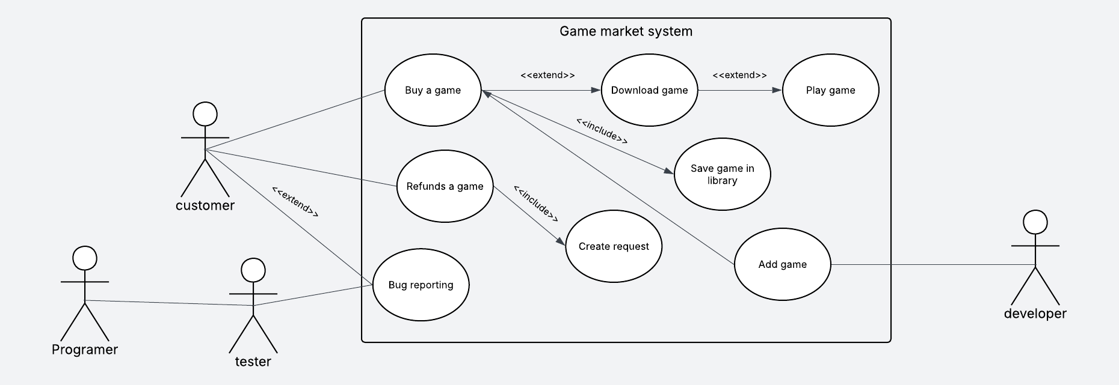
Figure 1. Class Diagram for GameStream Hub
This diagram defines the static structural model of the system. It showcases the inheritance hierarchy where the abstract 'User' class is specialized into four distinct roles: Customer, Developer, Tester, and Programmer. Additionally, it illustrates the relationships between users, games, orders, and the bug reporting system, including attributes and methods for each entity.
Key Class Descriptions:
- User (Abstract): The base class for all account types, handling authentication.
- Customer: Manages personal balance, library, and purchasing logic.
- Developer: Responsible for game uploads and sales analytics.
- Game: Contains metadata, pricing, and versioning info.
- Order: Represents a unique transaction between a Customer and a Game.
3. System Features
3.1. Game Purchase and Delivery
The system allows customers to browse the store, complete a purchase, and automatically add the title to their digital library.
3.2. Bug Reporting Lifecycle
Facilitates communication between the customer (who finds a bug), the tester (who verifies it), and the programmer (who fixes it).
4. External Interface Requirements
4.1. User Interfaces Overview
The system will feature a Graphical User Interface (GUI) built with modern design principles (e.g., Electron or Qt). It will include a dashboard for the library, a store page, and a dedicated bug report form.
4.3. Software Interfaces
Payment Gateway API: Integration for secure credit card and wallet processing.
File Storage System: For hosting and distributing large game installers.
4.4. Database Requirements
The system shall utilize a relational database to ensure data integrity and persistent storage. The following Entity-Relationship Diagram (ERD) defines the database schema, including primary keys, foreign keys, and cardinalities.
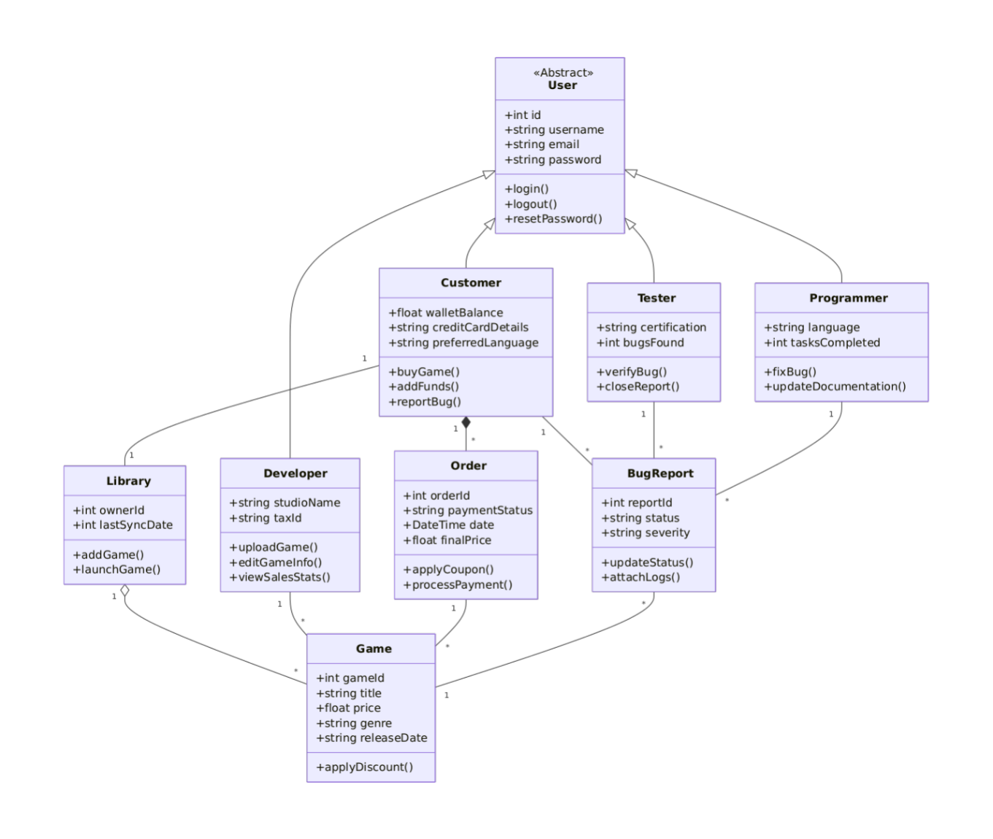
Figure 4. Entity-Relationship Diagram (ERD)
4.4.1. Data Entities Description
- Users Table: Stores account credentials and profile information.
- Games Table: Stores catalog information, pricing, and developer associations.
- Orders Table: Records every transaction, linking a specific Customer to a Game.
- Library Table: A junction table that connects Users to their purchased Games.
6. Nonfunctional Requirements
6.1. Performance
NF-1.1: The store page must load within 3 seconds under normal load.
NF-1.2: The system shall support at least 1,000 concurrent users.
6.2. Security
NF-2.1: User authentication must utilize secure hashing algorithms (e.g., Argon2 or BCrypt).

